INTERNATIONAL ORGANISATION FOR STANDARDISATION
ORGANISATION INTERNATIONALE DE NORMALISATION
ISO/IEC JTC 1/SC 29/WG 11
CODING OF MOVING PICTURES AND AUDIO

ISO/IEC JTC 1/SC 29/WG 11 N16316
Geneva, CH – June 2016

Source: WG11 (MPEG)
Title: MPEG Strategic Standardisation Roadmap

MPEG Strategic Standardisation Roadmap
In this document, MPEG lays out its medium-term Strategic Standardisation Roadmap, aimed at collecting feedback from the broadcasting, content and service provision, media equipment manufacturing and telecommunication industry, and anyone in professional and B2B industries dealing with media.
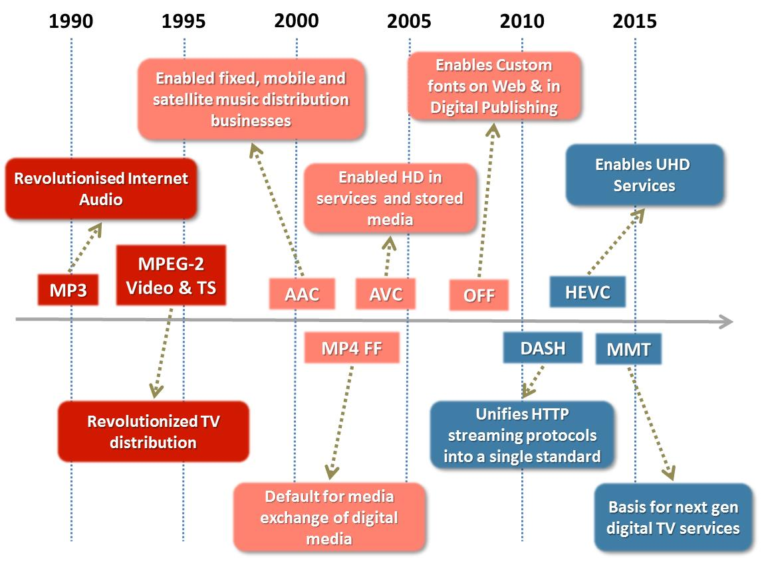
Figure 1 - MPEG Standards Enable Industries

MPEG Standards Enable Markets to Flourish
MPEG is an ISO/IEC standardisation group that has enabled huge markets to flourish through its standards. MP3 revolutionised the way music is distributed and enjoyed. MPEG-2 enabled the digital television industry to replace analogue TV, and has facilitated the expansion of satellite and Cable TV. MPEG-4 Advanced Video Coding (AVC) and High Efficiency Video Coding (HEVC) have also enabled large scale interactive media distribution. The ISO file format family (“mp4”) has enabled interoperable exchange of media files, while MPEG DASH powers the adaptive and optimised distribution of interactive media. See Figure 1 for an overview of MPEG’s cornerstone standards. (Please refer to Annex A for the acronyms).
MPEG serves not only B2C markets but also B2B content exchange (e.g. between TV studios and surveillance) and consumer-to-consumer communication in all modern smartphones. MPEG standards have enabled and continue to enable the creation and development of markets by providing interoperability while giving technology buyers options to choose from.
In its almost 30 years of existence, MPEG has gathered an increasing number of the world’s best experts in media technologies and accessed the best and most recent R&D results, Through an extremely thorough and competitive process, MPEG has created widely deployed, cross-industry standards that have enabled industries to converge.
MPEG works by proactively anticipating industry needs for standards. It can do so because it is firmly rooted in industry, with hundreds of industry representatives participating in its standardisation efforts. Once the need for a standard is identified, MPEG defines its requirements by interacting with its constituent industries, related standards committees, and industry fora. MPEG typically issues "Calls for Proposals" to obtain the best technologies which are integrated in its standards through a highly competitive process. This enables MPEG to produce timely standards that not just follow, but foment and lead technology developments. MPEG prides itself to adhere to its strict schedules, but is also able to quickly respond to emerging industry needs, as it did with MPEG DASH.
Demands from increasingly sophisticated technologies have prompted MPEG to extend the coverage of its standards from audio and video "compression" with support for "transport" (network and storage), to a range of media-related technologies as depicted below.
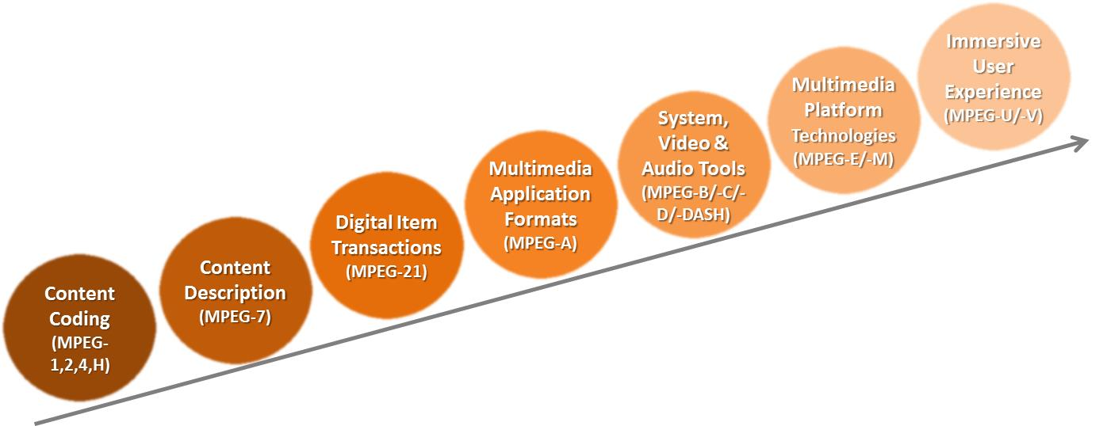
Figure 2 – Areas of MPEG Standardisation

MPEG has executed several standardisation projects represented by numbers (e.g. MPEG-4) and letters (e.g. MPEG-H). In some cases these represent bundles of technologies (e.g. MPEG-2 and MPEG-H) for well-defined services. In general, however, its standards can be independently combined to create specific media experiences.
Figure 3 below shows the delivery timeline of a selection of major MPEG standards organised along 5 categories: audio, video, graphics, media-related and systems.
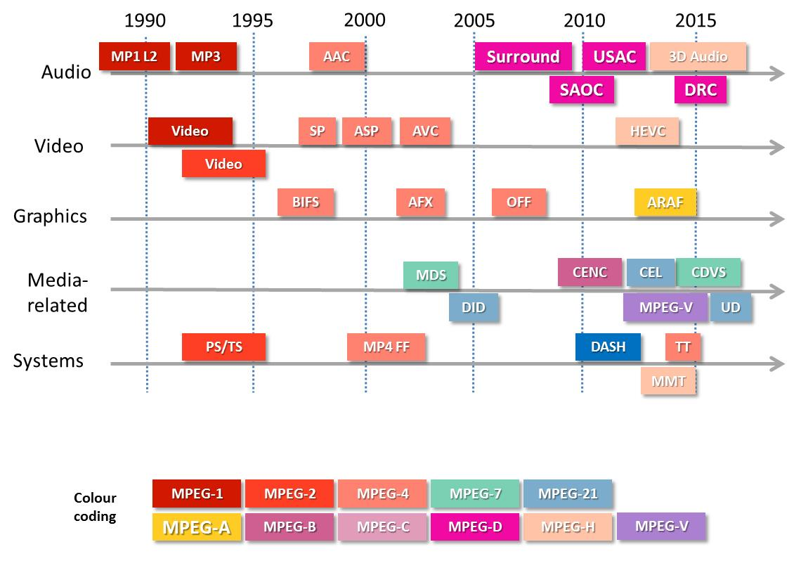
Figure 3 – Overview of MPEG Standards

MPEG Operates in a Dynamic Environment
The demand for all types of media content continues to grow and media data is expected to dominate communication traffic not just at peak demand times, but at every time of the day in the next few years. IP video will represent 80% of all global traffic in the next three years and three-fourths of all world-wide mobile traffic will be video by the year 2020 [1].
Growing trends in higher space-time resolution, higher dynamic range, wider colour gamut video, and immersive media (VR, AR, 360 panoramic, etc.) require increased bandwidth, low latency and improved services. As media communication industries move towards providing more personalized media experiences, devices must become more personal and must provide more immersive services. Augmented and virtual reality will give us more immersive experiences in film, television, voice and data markets, and these markets are forecast to grow many-fold in the next five years [2].
All types of devices and sensors will be part of the Internet of Things (IoT) and will be able to communicate not just plain data, but also audio-visual information. Of the 20 billion connected ‘things’ predicted in five years, 65% will be consumer-oriented [3]. This widespread adoption of the IoT will require new machine-to-machine media communication to provide enhanced capabilities that will augment sectors such as transportation systems (e.g., autonomous vehicles). Cloud computing and Big Data technologies evolve from basic data to rich audiovisual media, and enabling efficient search and discovery with everything connected will be key. This requires high levels of interoperability and efficiencies of communication to fuel market adoption and growth.

MPEG’s Five Year Roadmap
The following figure depicts MPEG’s current thinking on its roadmap for upcoming standards.
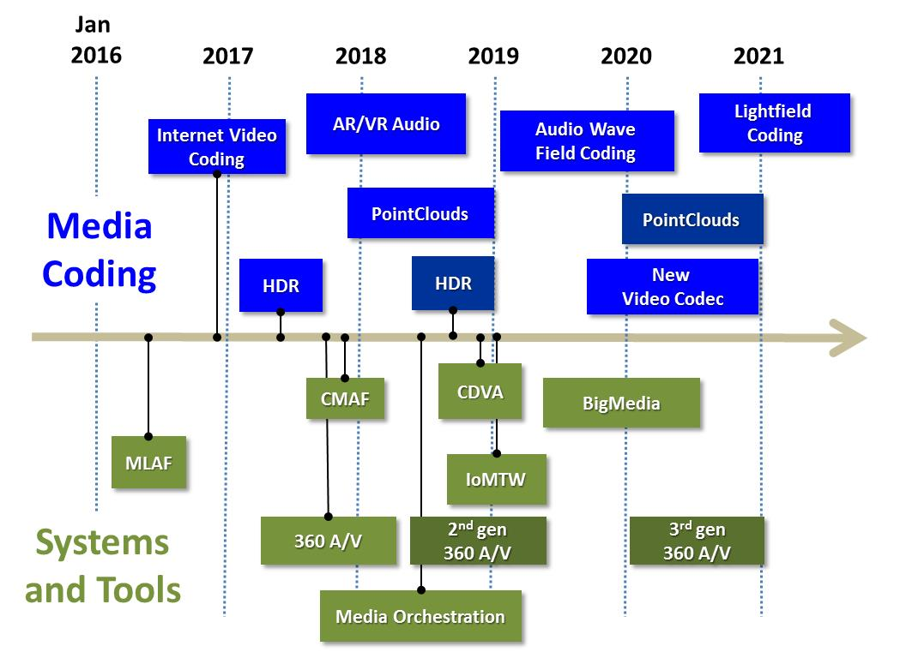
Figure 4 - MPEG Standardisation Roadmap. See Annex B for short project descriptions

MPEG will keep working on interoperable exchange formats for media for a variety of adaptive streaming, broadcast, download, and storage delivery methods, such as the Common Media Application Format (CMAF).
MPEG is further working on supporting better pixels (more and brighter colours and more contrast, also known as wide colour gamut and high dynamic range) in its existing HEVC standard. MPEG is now researching the next generation codec, suitable for ever higher resolutions, for larger (huge!) screens and for new distribution models including OTT and for next-generation networks, including 5G.
MPEG is also working to enable personal, immersive experiences. This includes augmented and virtual reality entertainment with immersive video and audio, as well as immersive media communication in real and virtual environments. With this work, MPEG caters to the needs of social media moving from text, via multimedia, to fully immersive experiences.
MPEG’s upcoming standards will empower new types of devices, like head-mounted displays and sensors, to be interoperable with services, and affordable to consumers. They will also enrich the capture of new types of media, including more immersive media, including 360 degree recording of audio and video producing MPEG-encoded surround sound, object based audio and video formats. MPEG has researched various forms of immersive TV, e.g. enabling users to freely select their viewpoint in their interaction with media content, and expects to publish a standard. Further, new MPEG standards will allow streaming non-AV environmental dimensions, like GPS coordinates. In doing so, it will become possible to integrate media from many different and heterogeneous sources into a single, coherent media experience.
MPEG doesn’t just optimise its coding standards to new delivery networks (e.g., 5G) and environments (e.g., automotive), it also provides the delivery methods attuned to the opportunities and constraints of these environments.
With its work on compact descriptors for search, MPEG enables content identification and search in vast media databases (“Big Media”). These standardised descriptors allow simple querying across diverse and heterogeneous databases empowering the automatic understanding of what is actually contained in the media itself.
Last but not least, upcoming MPEG standards will support an Internet of Media Things and Wearables, where MPEG standards facilitate the interoperable and efficient exchange of media data between these “Things”. This work will also allow automating the extraction of information from media data that machines and humans can understand, and act upon.

Share your Thoughts and Requirements
MPEG is building its future standardisation roadmap now, and we are advertising our plans so that industry can influence the direction of international digital media standardisation. If you represent an industry that relies on standards-based interoperability in audiovisual products, services and applications, MPEG would be very interested to hear about your needs and vision, for example by answering the following questions:
- Which needs do you see for media standardisation, between now and 5 years out?
- What MPEG standardisation roadmap would best meet your needs?
- To accommodate your use cases, what should MPEG's priorities be for the delivery of specific standards?
  - For example, do you urgently need something that may enable basic functionality now, or can you wait for a more optimal solution to be released later?
When providing your feedback, please note that MPEG is flexible in providing not only the desired technology, but also the level of integration across multiple technologies to meet an industry vertical’s specific needs. Note that MPEG plays no role in when and how standards become available on the market in the form of products and services (these are specific industries' and companies' decisions), but that we do have liaisons with relevant trade organisations. MPEG also plays no role in when and how relevant patents are licensed, as ISO rules prevent MPEG from handling licensing matters.
MPEG is organising a series of short, high level "Industry meets MPEG" workshops around the world, to collect market feedback, the first one of these to be held in Chengdu, China in the afternoon of Wednesday 19 October, 2016, and the next one will take place in Europe (place to be determined) on 18 January 2017. If you are interested in participating in such a workshop please contact Rob Koenen at rob.koenen@tno.nl.

References
- Cisco Visual Networking Index Report February 2016
- Digi-Capital Augmented/Virtual Reality Report 2015
- Gartner Symposium/ITxpo, Barcelona, Spain November 2015

Annex A - Acronyms
For more information, please refer to the MPEG website: http://mpeg.chiariglione.org/

AAC | Advanced Audio Coding
AFX | Animation Framework eXtension
ARAF | Augmented Reality Application Format
ASP | MPEG-4 Advanced Simple Profile
BIFS | BInary Format for Scenes
CDVA | Compact Description for Video Analysis
CDVS | Compact Description for Visual Search
CEL | Contract Expression Language
CENC | Common Encryption
CMAF | Common Media Application Format
DASH | Dynamic Adaptive Streaming over HTTP
DID | Digital Item Declaration
DRC | Dynamic Range Control (Audio)
FF | File Format
HDR | High Dynamic Range (Video)
HEVC | High Efficiency Video Coding
IVC | Internet Video Coding
MCO | Media Contract Ontology
MDF | Multimedia Description Scenes
IoTW | Internet of Media Things and Wearables
MLAF | Media Linking Application Format
MMT | MPEG Media Transport
MP1 L2 | MPEG 1 Layer 2 Audio
MP3 | MPEG 1 Layer 3 Audio
OFF | Open Font Format
OMAF | Omnidirectional Media Application Format
PS/TS | Program Stream/Transport Stream
SAOC | Spatial Audio Object Coding
SP | MPEG-4 Simple Profile
TT | Timed Text
UD | User Description
USAC | Unified Speech and Audio Coding

Annex B – Project Descriptions

HDR Video Coding
The HDR activity provides guidance on processing of consumer distribution high dynamic range video including conversions steps for going from a linear light RGB representation with BT.2020 colour primaries to a 10-bit, narrow range, ST 2084, 4:2:0, non-constant luminance Y’CbCr representation. The HDR System consists of four major stages; Pre-encoding processes, an Encoding process, a Decoding process, and Post-decoding processes as being shown in the figure below.
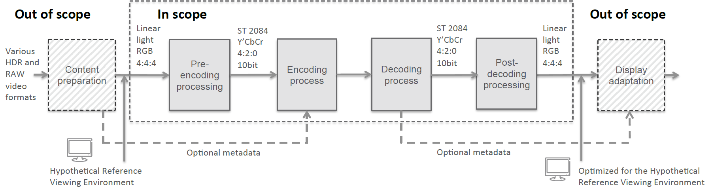
These four stages are applied sequentially with the output of one stage being used as input to the next stage according to the above-mentioned order. The primary purpose of the pre-encoding process is to convert the video input from its 4:4:4 RGB linear light, floating-point signal representation to a signal that is suitable for a video encoder. It is assumed that encoding and decoding is performed in a 4:2:0, 10-bit representation. An encoder is expected to make the best use of the encoding tools available according to a particular specification, profile, and level, given also the characteristics of the content and the limitations of the intended application and implementation. The decoding process on the other hand is fully described in the respective HEVC and AVC decoder standards, where a decoder must fully comply to the intended profile and level to output precisely reconstructed video samples from a given input bistream according to a deterministic decoding process, nominally over a time window indicated in the bitstream. The steps in the post-decoding process are aligned with what is commonly referred to as the non-constant luminance representation (NCL) in which colour conversion, to R’G’B’, is performed prior to applying the transfer function to produce linear RGB.

New Video Codec
The expanding use of more information rich digital video in diverse and evolving context and the still limited transmission and storage capabilities demand more powerful compression schemes. Reasons for this include the increases in fidelity, frame rate, and picture resolution for both stationary and mobile devices, the increasing number of users, the increased amount of video used by each user, and the increasing tendency towards individual use of download, upload, streaming, and security-related video services. Future standardization will address existing markets for video coding including terrestrial and satellite broadcasting, cable services, managed IPTV via fixed telecommunication services, Over-the-top services, professional content production and primary distribution, digital cinema and packaged media as well as surveillance, screen content and gaming.
It is anticipated that a new generation of video compression technology will be needed by the beginning of the next decade that has sufficiently higher compression capability than the HEVC standard and can particularly support professional high quality, high resolution and extended dynamic/colour-volume video, as well as user generated content. For some of the markets listed above, the new standard will strive to reduce the bitrate for storage and transport of video by 50%.
Special attention will also be given to support developing markets like augmented and virtual reality, unicast streaming, automotive applications and media centric Internet of Things. For these markets special attention will be given to seamlessly enable the required functionality by close integration with transport and storage to provide efficient personalized interactive services, as well as appropriate projections to enable VR applications. Therefore, though the further improvement of compression performance is expected to play the major role in this development, adaptation capabilities for usage in various network environments, a variety of capturing/content-generation and display devices are considered important as well.

Internet Video Coding
From the latest paradigm shifts from analogue to digital, from one standard codec to many competing codecs, from broadcast to internet streaming, there is an increasing demand for a video codec standard that can be made, used, and sold free of charge (“Type-1” in ISO/IEC language). MPEG’s Internet Video Coding (IVC) project is one of the first bottom-up approaches to design such a video coding standard in a standards body. MPEG aims to achieve a compression performance similar to the Advanced Video Coding (AVC) High Profile.
To achieve this goal, IVC employs a set of Type-1 tools that are either drawn from existing patents or published papers that are 20 years or older, or contributed by those who express their willingness to grant Type-1 licensing on their patents. MPEG plans to extend IVC by including new Type-1 tools in the near future, leading to new more performing profiles in the standard. Whenever MPEG becomes aware that certain tools are not Type-1, a profile without such tools will be developed.

Wave Field Audio
MPEG has provided ground breaking technology that facilitates the delivery of audio-visual media to the user. Such media may be digital cinema or TV programs, both of which assume that the user is at a stationary point when viewing and listening to the audio-visual content. In audio, this is the “sweet spot” located directly between the stereo speakers (or the centreline for 5.1 or a greater number loudspeaker layouts).
However, MPEG is moving to support less restrictive viewing conditions, such as flexible “point of view” media in which a viewer can move to various positions in front of a viewing screen and see a realistic presentation that is true to that point of view. In a similar way, the audio signal needs to change with the varying positions that the viewer might take. This is not just “enlarging” the sweet spot, but rather changing what the user hears as his or her position changes.
Wave Field capture and synthesis is a technology that fully supports this use case, in that it can capture and reproduce the exact acoustic pressure waves at every point in a space in front of the visual display. It is a spatial audio capture and rendering technique in which an array or grid of microphones is used to capture the exact acoustic wave pattern as produced by some sound scene. When rendering, an array or grid of loudspeakers is used to reproduce the same acoustic wave pattern in the listener area as would be created from the real sound scene. Contrary to traditional reproduction techniques such as stereo or surround sound, with Wave Field techniques the localization of synthesized virtual sources remains accurate anywhere within the listening area. This technique can be used to capture a real acoustic sound scene, or to record a synthesized acoustic scene via propagation of modelled acoustic waves from a virtual source to a virtual array or grid of microphones.

Tools for Virtual Reality
The market is rapidly adopting to Virtual Reality (VR) to provide immersive experiences that go beyond what even a UHD TV can offer. To enable a true-to-life VR experience, immersive video is essential. Interactivity between the user and the content, high quality video (HDR, increased spatial resolution), and efficient delivery over existing networks are required.
There is a strong market momentum and interest in VR with a rapid increase in number of companies providing cameras, content and devices for VR. Since there are no existing standards for VR, the lack of interoperability is a significant challenge in the current marketplace. Therefore, MPEG has started standardization of essential VR technologies, to prevent fragmentation in VR marketplace and to enable VR services and applications to thrive in the mass market.
MPEG plans to standardize optimized video coding technologies for VR, delivery mechanism, the application format, and other relevant VR technologies. The first specification aimed at VR is the Omnidirectional Media Application Format (or “OMAF” in MPEG lingo); it will cover 3D projection methods and related metadata and signalling.

Compact Descriptors for Video Analysis (CDVA)
MPEG has recently completed the work on Compact Descriptors for Visual Search (CDVS), which enables efficient search in large-scale image collections. While this standard is an important step forward, there are still open challenges from the large and quickly growing amount of video, for example, in the media and entertainment industry, in the automotive industry and in surveillance applications. Video is more than a collection of images, and the temporal redundancy of video as well as the spatiotemporal behaviour of objects in the video need to be taken into account.
CDVA aims at developing tools to analyse and manage video content, including search for object instances in video, categorisation of scenes and content grouping, based on compact descriptors for video, which can be efficiently matched and indexed for large-scale video collections. The ongoing work on CVDA targets search and retrieval applications, aiming to find a specific object instance in a very large video database (e.g., a specific building, a product). Applications include for example content management in media production, linking to objects in interactive media services and surveillance.

Media Linking Application Format (MLAF)
The “Media Linking Application Format” standard has been prompted by many examples of existing services where media transmitted for consumption on a primary device give hints to users to consume related media on a secondary or companion device. Interoperability of such services is facilitated if there is a data structure (a “format”) that codifies the relationship between these two media. MLAF defines a standard representation for these relationships and calls them “bridgets”, i.e. links between a source content item and one or more destination content items. This representation is based on the MPEG-21 Digital Item.
Bridgets can be products of an editorial decision, and can be the output of a workflow which involves different roles taking care of finding, organising and finally crafting the data that constitute them. In this workflow actors with different roles define bridgets from different perspectives. Authors of TV programmes will define bridgets following criteria matching the editorial intention of the programme, the main distribution channel or the target audience of the programme. At the same time marketing and commercial operators (e.g., advertisement agents, sales houses) will define bridgets following their own objectives, which may be independent from the authorial perspective. Last, but definitely not least, end users can define their own bridgets through social media interaction. All the above approaches can include not only the generation of the linking information but also of information related to how referenced content have to be presented graphically or should interact with the user.
Therefore the Media Linking Application Format (MLAF) offers a standard format for representing and exchanging bridget-related information that fosters integration of all those systems playing a role in generating bridget information in the different and heterogeneous aforementioned domains.

Light Field Coding
To reach a high degree of realism in Virtual Reality (VR), high resolution color images of the scene need to be captured and processed adequately, which involves image fusion and panoramic stitching. 360 degree VR, for instance, provides an immersive feeling by positioning the user in the centre of one or two (for stereoscopy) spherical/cylindrical panoramic texture(s) obtained from multi-camera stitching, out of which a particular viewport is selected from the user’s head direction.
Next-generation Cinematic VR should provide an even better, authentic virtual viewing experience, fully indistinguishable from what the user would experience in the real world. Similar to the Matrix bullet effect, it should support free navigation to any position in the scene with correct motion parallax and depth cues, as well as correct eye accommodation and focus to the display, eventually reaching glasses-free 3D all-around viewing. Light Fields, describing light information at all positions and from all viewing directions of the scene, provide the necessary means to reach these goals. Practical systems include multi-camera acquisitions (possibly including depth sensing cameras), lenslet light field cameras (multiple mini-cameras in-a-box), autostereoscopic and light field head-mounted devices and displays.
To reduce transmission bandwidth requirements in Light Field coding, depth-based editing and so-called depth image based rendering techniques, generating additional viewpoints from a small number of transmitted camera views, are studied towards optimal trade-offs in end-to-end system performance (acquisition, coding, rendering) and user experience (reduced latency and cyber sickness, depth-based image editing satisfaction, etc.).
Audio Wave Field Coding should – similar to the visual rendering – recreate the sound field from any position the user takes in the scene. Light Field Coding and Audio Wave Field Coding are complementary tools to achieve a next-generation Cinematic VR experience.

Point Cloud Compression
We are witnessing a major paradigm shift in capturing the world. If some time ago 2D pictures and videos were enough and content consumption was restricted to 2D displays, there are now more and more devices for capturing and presenting 3D representations of the world.
The easiest way of capturing the 3D information is by associating the depth with each captured pixel. By doing this from various angles, it is possible to reconstruct 3D points. An object or a scene is then a composition of such objects forming what is known as “point clouds”. These structures can have attributes such as colors, material properties and other attributes.
Point clouds typically use thousands up to billions of points to represent scenes that can be realistically reconstructed. MPEG’s point cloud compression standard targets both lossy compression for, e.g., real-time communications, and lossless compression, for GIS, CAD and cultural heritage applications. Point clouds are typically captured using multiple cameras and depth sensors in various setups, but as usual in MPEG, acquisition is outside of the scope of the standard. The standard targets efficient geometry and attribute compression, scalable/progressive coding, as well as coding of sequences of point clouds captured over time. The compressed data format should support random access to subsets of the point cloud.

Internet of Media Things & Wearables
The phrase "Internet of Things" (IoT) encompasses a large variety of research, development and market efforts related to the communication between smart objects. The definition may be fuzzy, but the market reality is very clear: the number of devices connected to the Internet will reach 50 billion by 2020. An important factor contributing to the growing adoption of IoT (Internet of Things) and IoE (Internet of Everything) is the emergence of wearable devices, a category with high growth market potential. Wearable devices are commonly understood to be devices that can be worn by, or embedded in, a person, and that have the capability to connect and communicate to the network either directly through embedded wireless connectivity or through another device (primarily a smartphone) using Wi-Fi, Bluetooth, or another technology.
In order to offer interoperability in such a dynamic market, several international consortia have emerged, like the Internet Industrial Consortium (IIC), the Alliance for Internet of Things Innovation (AIOTI), the Internet of Things Architecture (IoTA), the WSO2 reference architecture for the IoT, oneM2M and OIC, to mention but a few. As these consortia focus on specific challenges, following their own specific requirements, MPEG identified the need for ensuring the interoperability among IoT systems, where MPEG focuses on multimedia content processing to enable an “Internet of Media Things”.
MPEG’s specific aim is to standardize the interaction commands from the user to the “Media Thing” or wearable device, the format of the aggregated and synchronized data sent from the Media Thing or wearable to external connected entities, as well as identify a focused list of Media Wearables to be considered for integration in multimedia-centric systems.

Common Media Application Format (CMAF)
The Common Media Application Format (CMAF) will set a clear standard for a format optimized for large scale delivery of a single encrypted, adaptable multimedia presentation to a wide range of devices. The format is compatible with a variety of adaptive streaming, broadcast, download, and storage delivery methods.
The segmented media format, which has been widely adopted for internet content delivery using DASH, Web browsers, commercial services such as Netflix and YouTube, is derived from the ISO Base Media File Format, using MPEG codecs, Common Encryption, etc. The same components have already been widely adopted and specified by many application consortia, but the absence of a common media format, or minor differences in practice, mean that slightly different media files must often be prepared for the same content. The industry will greatly benefit from a common format, embodied in an MPEG standard, to improve interoperability and distribution efficiency.
CMAF defines a standard for encoding and decoding of segmented media. While CMAF defines only the media format, CMAF segments can be used in environments that support adaptive bitrate streaming using HTTP(S) and any presentation description, such as the DASH MPD, the Smooth Streaming Manifest, and the HTTP Live Streaming (HLS) Manifest (m3u8). MPEG’s CMAF specification is addressing the most common use-cases and defining a few CMAF profiles that would help industry and consortia to reference this specification and avoid fragmentation of media formats.
Some of the major use cases for CMAF include OTT adaptive bitrate streaming, broadcast/multicast streaming, hybrid network streaming of live content, download of streaming files for local playback, and server-side and client-side ad insertion.

Big Media
A huge amount of data comes from audiovisual sources or has a multimedia nature. However, audiovisual data are currently not incorporated in the Big Data (standardization) paradigm. The objective of MPEG’s Big Media work is to provide the standards specific for audiovisual data in order to make it exploitable and usable for different application use cases.
MPEG currently has started analysing the need for Big Media standards. A set of use cases was collected and analysed with regards to the existing MPEG standards. This work is conducted in collaboration with ISO/IEC JTC 1 WG 9, which is defines the Big Data Reference Architecture (BDRA).
Within this framework, MPEG has identified a number of existing MPEG standards that can handle different parts or aspects of this Reference Architecture. As an example, MPEG developed a very rich set of audio-visual descriptors that can be used for media data curation. MPEG-7 in general, and more recently the work related to Compact Descriptors for Visual Search (CDVS) are good examples. Other MPEG tools have been also identified to be useful for media data collection, analytics, and visualization.
The current focus is on standardization gap analysis and on the development of a conceptual model for media-related functionalities in Big Data.

Media Orchestration
The amount of multimedia capture and display devices is still growing fast – every phone or tablet can record and play multimedia content. Applications and services move towards a more immersive experiences, and we need tools to be able to manage such devices over multiple, heterogeneous networks, to create a single experience. In other words: we need tools to coordinate media that is recorded by many devices simultaneously and that can be consumed on different devices, simultaneously. AN example is a TV and a tablet that show different views of the same event, in sync. We call this process Media Orchestration: orchestrating devices, media streams and resources to create such an experience. Media orchestration:
- Applies to capture as well as consumption;
- Applies to fully offline use cases as well as network-supported use, with dynamic availability of network resources;
- Applies to real-time use as well as media created for later consumption;
- Applies to entertainment, but also communication, infotainment, education and professional services;
- Concerns temporal (synchronization) as well as spatial orchestration;
- Concerns situations with multiple sensors (“Sources”) as well as multiple rendering devices (“Sinks”), including one-to-many and many-to-one scenarios;
- Concerns situations with a single user as well as with multiple (simultaneous) users, and potentially even cases were the “user” is a machine. There is an obvious relation with the notion of “Media Internet of Things” that is also discussed in MPEG.

The figure contains a number of elements that are already part of the MPEG work plan – the elements with an explicit link to the timeline. The other elements are under consideration; MPEG has not yet formally committed to develop such standards, and the timing of them is indicative.

