ISO/IEC JTC 1/SC 29/WG 11 N 18538

ISO/IEC JTC 1/SC 29/WG 11
Coding of moving pictures and audio
Convenorship: UNI (Italy)

Document type: | WG 11 document
Title: | Notice of the 127th WG 11 meeting
Status:
Date of document: | 2019-xx-xx
Source: | JTC 1/SC 29/WG 11 Secretary
Expected action: | INFO
No. of pages:
Email of convenor: | leonardo@chiariglione.org
Committee URL: | mpeg.chiariglione.org

INTERNATIONAL ORGANISATION FOR STANDARDISATION
ORGANISATION INTERNATIONALE DE NORMALISATION
ISO/IEC JTC 1/SC 29/WG 11
CODING OF MOVING PICTURES AND AUDIO

ISO/IEC JTC 1/SC 29/WG 11 N18538
Gothenburg, SE – July 2019

Source: | Leonardo Chiariglione
Title: | Notice of the 127th WG 11 meeting

Notice of the 127th WG 11 meeting

The 127th WG 11 meeting will take place on 2019/07/08T09:00-12T20:00 at the Clarion Post Hotel, Gothenburg, Sweden.
The meeting will be preceded by:
- The JVET meeting starting on the 3th.
- The JCT-VC meeting starting on the 5th.
- Ad hoc group meetings on the weekend (7th-8th).
Facilities fees apply (490 EUR Early Bird facilities fees until 14.05.2019). Access to the meeting will not be refused to those who do not pay the facilities fees. However, the host may at their discretion, deny access to internet, coffee and other facilities.

MEETING VENUE
Clarion Post Hotel
Drottningtorget 10
411 03 Gothenburg
Sweden
Tel: +46 31 61 90 00
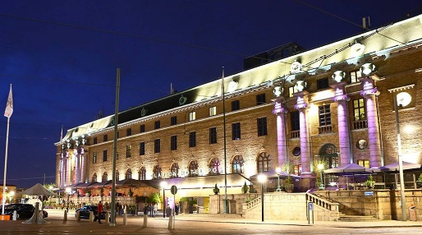

MEETING WEB SITE
Meeting information, registration, hotel information and local information can be found at the following website.
http://kenzler-conferences.de/mpeg127/

MEETING ORGANIZER
Silke Kenzler Conference Management
Karla-Schmidt-Str. 14
D-30655 Hannover
Germany
Tel: +49 (0)511 65581860
E-Mail: office@kcmweb.de

DESTINATION INFORMATION
Gothenburg is the second largest city of Sweden and the fifth-largest of the Nordic countries.
It is situated on the west coast of Sweden and was founded as a heavily fortified, primarily Dutch, trading colony in 1621.
The city is encircled by rocky shoreline, deep forests, tranquil lakes and the surging sea to the west. No other Swedish city gives such easy access to nature. Right on the doorstep are wide open spaces and magical islands.
Due to Gothenburg’s advantageous location in the center of Scandinavia, trade and shipping have always played a major role in the cities economic history. Gothenburg port has come to be the largest harbor in Scandinavia.
Gothenburg is an open and accessible city. It offers almost everything you would expect of a cosmopolitan city – within walking distance. All you need is right in the city and you can get everywhere on foot – from the Central Station to your hotel, to the arenas, shopping, restaurants and nightlife.

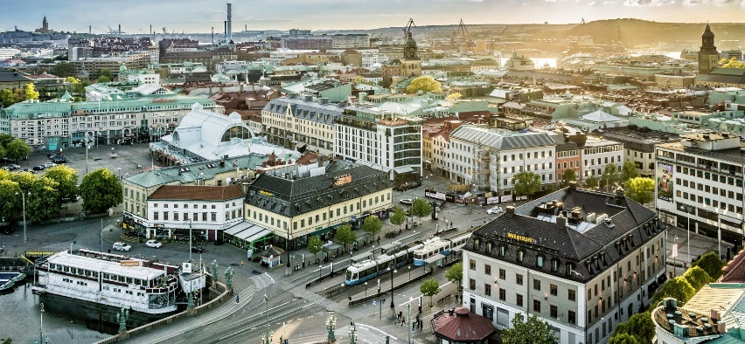

TRAVEL DOCUMENTS AND VISAS
If you are visiting Sweden on a business or conference trip and are a citizen of a non-EU country, you may need a visa. A visa is a permit to travel to and stay in a country for a limited period. To be granted a visa, you need an invitation letter from the company or person who is arranging the conference.
Visit this WEBSITE to find out whether you need a visa or not.
Invitation letter
If you need a letter of invitation, please fill out the Invitation letter form and send it by email to office@kcmweb.de as early as possible, in order to leave plenty of time to process the application. Please do allow 72 working hours to process your request.
Note that registration must be made before requesting an invitation letter.

REGISTRATION AND INFORMATION DESK
The registration and information desk will be open from Wednesday, 03 July to Friday, 12 July 2018 from 08:00 to 18:00. You will receive your name badge upon check-in. Your name badge is required for admittance into meeting room.

ACCOMMODATIONS
Please note that the hotels in Gothenburg are very high frequented in July. Therefor we recommend to use the room contingents we ordered for you at the hotels you find below.

Clarion Hotel Post****
The meeting venue is at the Clarion Post, a hotel located in central Gothenburg and neighboring the Central Station.
To book a room at the Clarion Post Hotel please email group.post@choice.se and provide the booking reference: MPEG – 2099GR01649
Prices: 02.07. – 07.07.2019: 142€ per night
08.07. – 14.07.2019: 123€ per night

Clarion Collection Hotel Odin****
To book a room at the Clarion Collection Hotel Odin please email reservation.cc.odin@choice.de and provide the booking reference MPEG – 2074GR002317
Prices: 02.07. – 07.07.2019: 142€ per night
08.07. – 14.07.2019: 114€ per night

Comfort Hotel Göteborg***
To book a room please email co.goteborg@choice.se and provide your booking reference MPEG – 2125GR005465.
Prices: 02.07. – 07.07.2019: 120€ per night
08.07. – 14.07.2019: 100€ per night

Hotel Eggers****
To book a room at the Hotel Eggers please email info@hoteleggers.se or call +46 31 333 44 40. The reservation number is 331447
Price: 105€ per night

Scandic Europa****
To book a room please go to the website: www.scandichotels.com
Choose Scandic Europa. Insert the dates you would like to book and use the booking code: BKCM020719
For individual reservation please call +31 467516500.
Price: The prices on the hotel website are valid

Hotel Opera ****
To book a hotel room please email reservationhotelopera@profilhotels.se and provide the booking reference: 016060
Prices: Single room: 130€
Double room: 142€

GETTING TO THE CITY
The Gothenburg Landsvetter Airport is an international airport, 25km east of Gothenburg.
It takes 20 minutes to travel by Flygbuss Airport Coach between the airport and Gothenburg center. In the center, there are bus stops at Korsvägen, Kungsportsplatsen, Nils Ericson terminal and Park Aveny. At the airport, the buses are located directly outside the check-in hall and departures up to every 12 minutes.
Tickets and more information
Flygbussarna's website
Telephone: +46 (0)771 51 52 52
Flygbuss to the city center: from 10€

Taxi to the city center: from 32€
Taxi companies: Taxi Göteborg Tel: +31 (0)650000
Taxi Kurir Tel: +31 (0)272727
Minitaxi Tel: +31 (0)140140

LOCAL ATTRACTIONS:
Liseberg
Gothenburg Museum of Art
The Garden Society
Universum
The Gothenburg Aprichelago
Slottsskogen

TIME ZONE
Gothenburg is on central European Time (CEST)

CLIMATE
The average July temperature is 20°C high and 11°C low

ELECTRICITY
The voltage in Gothenburg is 230 Volts, 2 round pin plugs are standard

