INTERNATIONAL ORGANISATION FOR STANDARDISATION
ORGANISATION INTERNATIONALE DE NORMALISATION
ISO/IEC JTC 1/SC 29/WG 11
CODING OF MOVING PICTURES AND AUDIO

ISO/IEC JTC 1/SC 29/WG 11 N15067
Warsaw, PL – June 2015

Source: | Leonardo Chiariglione
Title: | MPEG 112 meeting notice

The 112th MPEG meeting will be held at

Marriott Hotel Warsaw
Aleje Jerozolimskie 65/79 - 00697 Warsaw - Poland
Tel. +48 22 630 63 06 - www.marriott.de

on 22-26 June 2015.

Hosted by

Poznań University of Technology
Chair of Multimedia Telecommunications and Microelectronics
Polanka 3,60965 Poznań, Poland

Organized by

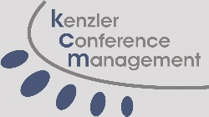

www.kcmweb.de

Registration

Facility fees for all meetings
Advanced registration  (until 2015-05-21) | Regular rate  (from 2015-05-22)
490 EUR | 590 EUR

Cancellation penalties
- 50 EUR before 2015-05-29.
- 50% before 2015-06-12.
- No refund from and after 2015-06-12.
- Other fees (f.e. changing name, billing adress) 50 EUR

Facility fee includes
- Meeting facilities, including A/V equipment and wireless Internet access.
- Coffee-breaks.

Registration

Please make your registration here.
For questions regarding payment please contact kenzler conference management.

Visa
Citizens of all countries of the European Union, Switzerland, Croatia, Israel, Japan, Australia, New Zealand, most of the countries of North and South America, and some other countries do not need a visa: a valid passport suffices to enter Poland. In case of doubt please contact the the Ministry of Foreign Affairs of the Republic of Poland well in advance before departure.
Travellers requiring a visa can travel freely throughout the Schengen zone for three months with a Schengen visa issued by any Schengen country. Obtaining a visa entitling you to visit one Schengen country automatically entitles you to travel to and from all the other Schengen countries too.
Exceptions:
Visas are required for citizens of Great Britain and Ireland Russia, Belarus and Ukraine.
If you need a letter of invitation, please fill out the template letter below and send it by email to kenzler conference management as early as possible, in order to leave plenty of time to process the application. We suggest submitting it before 2015-04-09.
Note that the registration have to be made before requesting an invitation letter.
invitation letter

General Information

Wep pages

MPEG 112 JPEG 69

Meeting venue
Marriott Hotel Warsaw
Aleje Jerozolimskie 65/79 - 00697 Warsaw - Poland
Tel. +48 22 630 63 06 - www.marriott.de

Poznań University of Technology
Chair of Multimedia Telecommunications and Microelectronics
Polanka 3,60965 Poznań, Poland

Meeting venue

kenzler conference management
Silke Kenzler
Karla-Schmidt-Str. 14,D-30655 Hannover,Germany
Tel. +49.51165581860,office@kcmweb.de

Venue
All meetings take place in the
Marriott Hotel Warsaw (Aleje Jerozolimskie 65/79, 00697 Warsaw, Polen).

Please note: This hotel does not provide shuttle service.

Getting there from WAW(Warsaw Chopin Airport)
The distance from the airport to the meeting venue is about 7 km.
Visit the WAW website for more informations.
Taxi: estimated 50 PLN / 12€ (one way)
Bus : 5 PLN / 1,50€ (one way)
Bus 175 - Stop at AL . JEROZOLIMSKIE (Central Railway Station)
Running daily between 04:58 - 23:27

Alternate transportation: ELE Taxi: 80 PLN (one way) ;reservation required
for more information please visit the ELE Taxi Website.
Please note that there is no multilingual version of the ELE Taxi website

How to get there from the Train Station
Station: Central Station 350 m 1 minute walk to venue

More information about public transport

Bus:
Standard bus lines are numbered from 100 to 399. The range 300-399 includes seasonal lines which are activated at specific times of days of week. These buses stop at all stops.
Lines 400-599 are bus fast lines with fewer stops. Lines numbered 400-499 run at selected times of day or week.
It is worth checking the map of a given line first

Tram:
Tram lines are numbered from 1 to 79. Numbers 1-39 include basic connections.
Tram lines with numbers from 40 to 49 run at specific times of day or week (e.g. during traffic peak hours)
All tickets are valid on trams. Trams stop at all stops on a given route. All stops are permanent.
To find out more about bus and tram times, routes and tickets, go to the ZTM Website.
For even more details see F.A.Q.

Hotels
Click here for our MPEG-Warsaw-Map .
 | Distance to |  | Room price around | Booking
 | Venue | City | Single (Double)
Marriot Hotel Warsaw  Standard room  Executive Floor | 0,00 km | 0,25 km | 114,- (125,-) EUR 163,- (174,-) EUR | Form
Polania Palace | 0,45 km | 0,25 km | 150,- (160,-) EUR
Metropol Hotel | 0,50 km | 0,10 km | 90,- (100,-) EUR
Novotel Centrum | 0,65km | 0,18 km | 95.84 (103,70,-)
IBIS Warzawa Centrum | 0,65 km | 0,19 km | 60,- ( 65,-) EUR
Reytan Hotel | 3,20 km | 3,80 km | 67,- ( 77,-) EUR
Novotel Warzawa Airport | 5,30 km | 6,00 km | 84,- ( 91,-) EUR
Hotel Hetman | 5,30 km | 4,60 km | 79,- ( 89,-) EUR
Best Western Hotel Felix | 7,10 km | 6,60 km | 53,- ( 60,-) EUR

Room contingent
A contingent of rooms are reserved at the Marriott Hotel for the meetings with the password "MPEG/JPEG". Please put the password in your reservation-mail.
Please note: All prices include breakfast and taxes.
Check also online booking systems to get lower offers for the aforementioned hotels.

Restaurants/Shopping
Polish cuisine has evolved over the centuries to become very eclectic due to Poland's history.
It is rich in meat, especially pork, chicken and beef (depending on the region) and winter vegetables and spices.
Generally speaking, Polish cuisine is hearty and uses a lot of cream and eggs.
Click here for our MPEG-Warsaw-Map to see your locations. Or download the map as PDF.

Ale Gloria
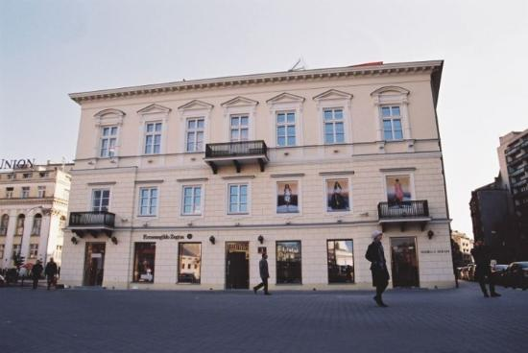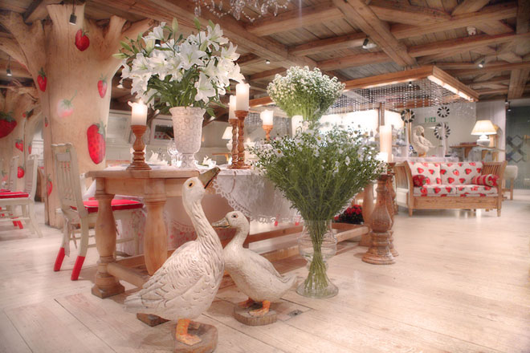
Adress: Trzech Krzyży 3, Warsaw
Magnificent, enjoyably over-the-top restaurant in the finest part of Warsaw where the strawberry-themed decor appears amazingly at home and where the food - often featuring strawberries - will leave you determined to come back for more

U FUKIERA
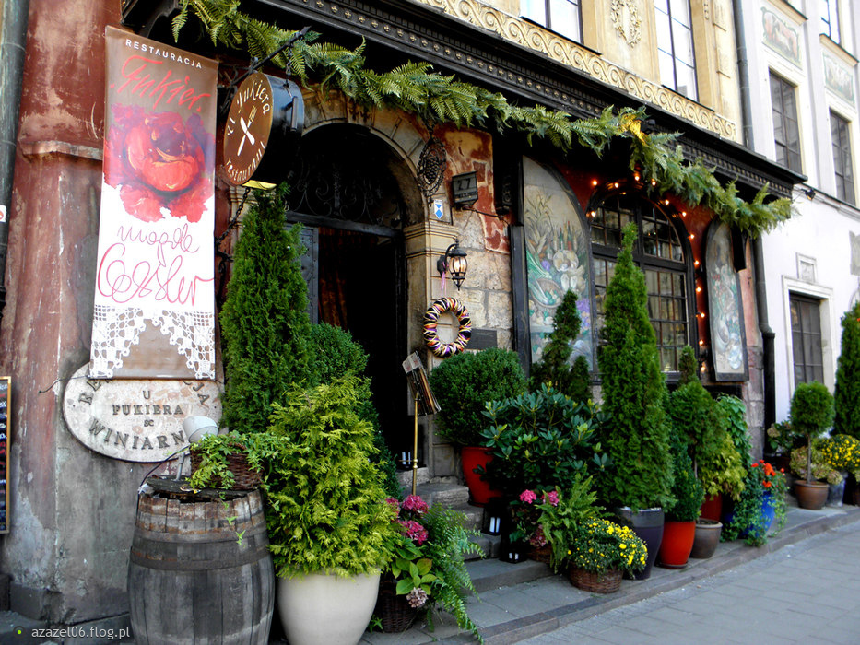
Adress: Rynek Starego Miasta 27, Warsaw
Fukiera is Warsaw’s oldest restaurant and without doubt it is also the most famous.
The atmosphere is a unique mix of medieval and old aristocracy, while the menu is a lavish version of traditional Polish cuisine. Candlelight in combination with a superb wine list set the mood for the perfect romantic evening in an environment that will transfer you to a different era. Grilled steak is the speciality dish and there is a varied choice of fresh fish. The restaurant is situated in the vibrant Old Town, ideal for taking in a stroll after your meal.

The Belvedere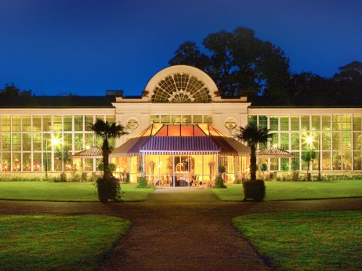
Royal Bath Gardens, an extraordinary location perfectly reflected in the style and atmosphere of the restaurant itself.

PAPAYA RESTAURANT
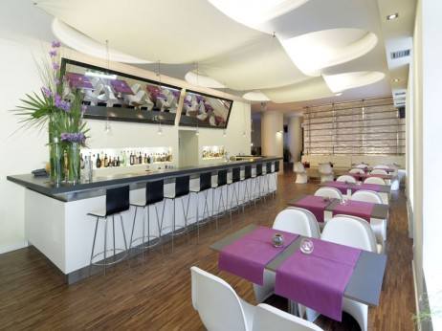
Papaya is one of the many restaurants in Warsaw that represents a new craze for Asiatic cuisine. A fusion of Thai, Japanese and Chinese dishes are prepared by native chefs, while many of the ingredients are imported from the Far East. The décor is minimalist monochrome with discreet Oriental touches such as the only oyster aquarium in Poland, which gives the restaurant an elegant look.
Opening times please see F.A.Q.

Sightseeing
There are many reasons to fall in love with Warsaw and we just wanna share a few of them with you. Warsaw, nurturing over 400 years of pride as a capital, is Poland´s largest city and an economic, political and cultural centre. The symbol of the city is the Mermaid featured on the city seal. Warsaw is a bustling metropolis and features an unforgettable history. Feel the spirit of competition and innovation.
You will find further information here.
Click here for our MPEG-Warsaw-Map to see your locations. Or download the map as PDF.

Old town
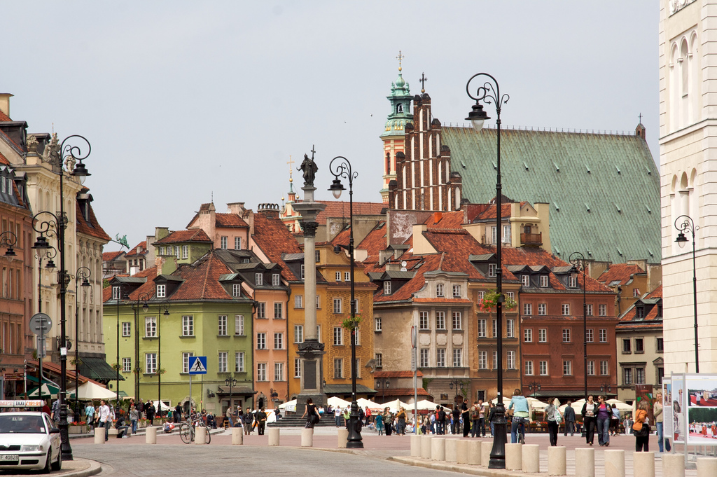
Walking the streets of the Old and New Towns allows you to rest from the the bustle of central city life. Atmospheric alleys, squares, and cosy cafés create a unique sense of history, and in the summer, the Old and New Town Squares become stages for musical and theatrical performances and open-air galleries.

The Royal Castle in Warsaw
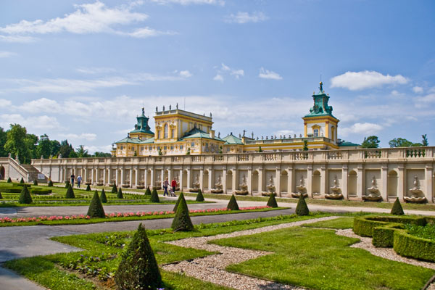
The Wilanów Palace is one of the most precious monuments of Polish Baroque. Built for King Jan III Sobieski at the end of the 17th century and gradually expanded by successive owners, it represents an unusual combination of a traditional Polish court with an Italian rural villa and a French chateau. The interiors of the palace, with their original design and decadent furniture, represent three style eras.

Copernicus Science Center
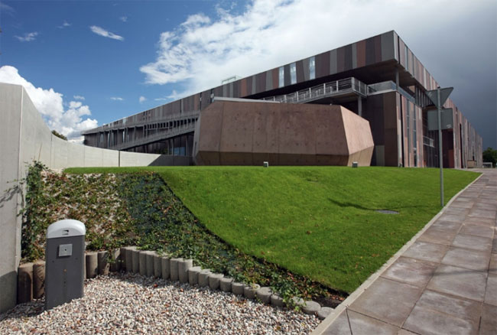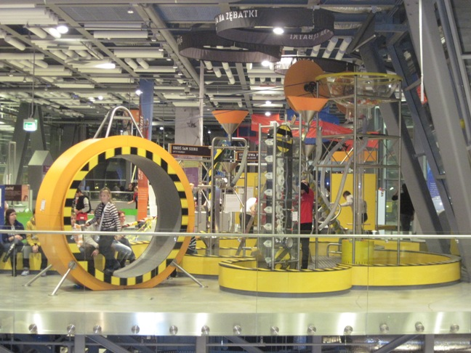
A kingdom of experiments and a heaven for those interested in the world. Here everyone can delve into nature’s mysteries, conduct experiments on their own and, above all, have fun.

Multimedia Fountain Park
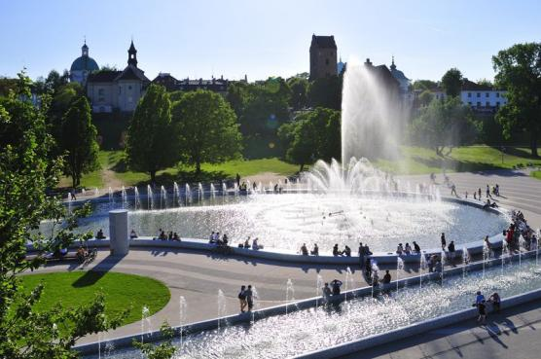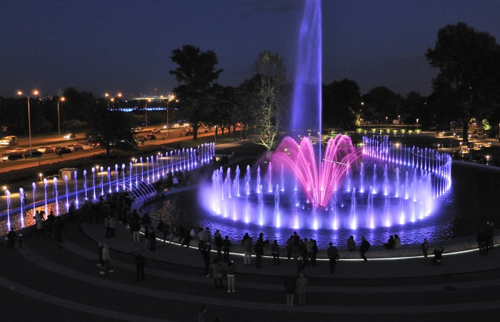
Warsaw has now joined these cities - since May 2011 it has had a new tourist attraction - multimedia fountains at the foot of the castle. They are located in an enchanting place, near the Old Town and the Vistula.
Up to 30 thousand litres of water a minute stream out of 367 nozzles. The streams are lit with colourful light from nearly 300 LED reflectors. In time intervals, impressive laser animations appear on the mist from nebulised water.
The ‘Water – Light – Sound’ multimedia shows take place each Friday and Saturday from May till September at 9.30 pm (May and October - 9 pm).

National Museum
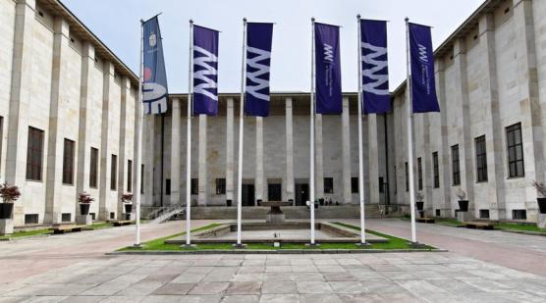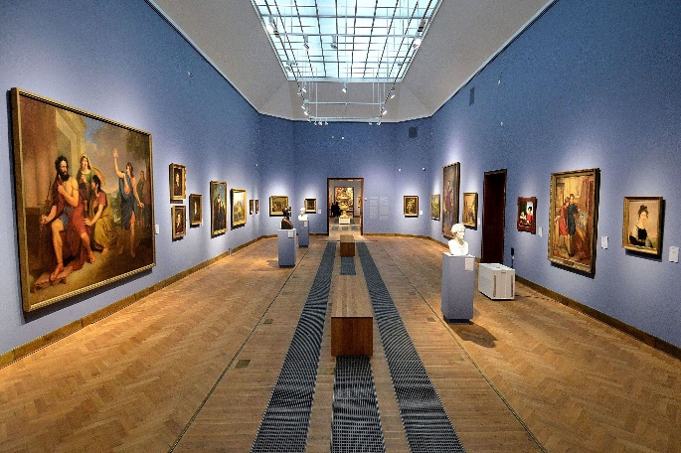
The museum contains a rich collection of exhibits from antiquity to modern times. The building originates from the inter-war period. During the World War II it secretly stored some of the Royal Castle treasures. It organizes numerous temporary exhibitions presenting art from all over the world. The Vistula-side building wing is the Museum of the Polish Army presenting the history of Polish military featuring an interesting outdoor exhibition.

Łazienki Królewskie Museum Park
Łazienki Królewskie Museum is a Palace-Garden complex which includes a park (76 hectares of nature, right in the city center) and numerous historical objects. The park was created using the formerly wildly growing forest, allowing the animals to be 'detained' under natural conditions. In the 18th century it became the most beautiful planned area in Warsaw and one of the most beautiful in Europe, equally stunning in terms of its greenery and architecture.
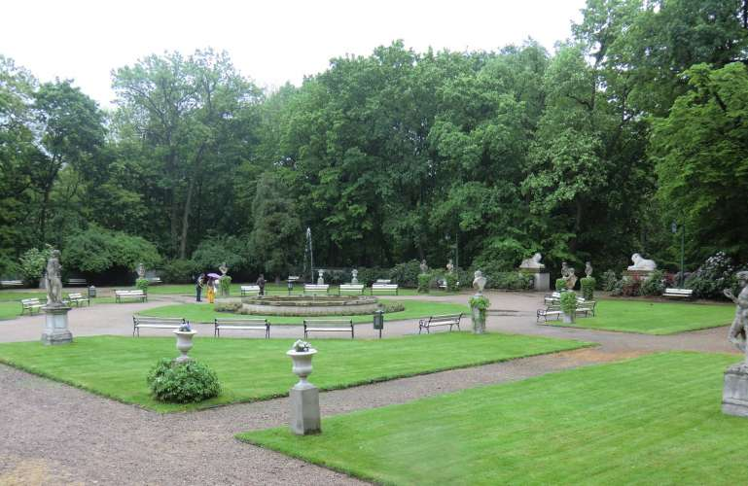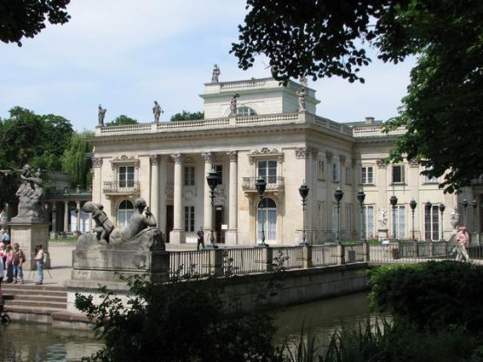
Łazienki performs a variety of functions: it is a museum, a place of cultural, scientific and entertainment events, and a favourite place for walks. It is also an important place for music lovers. For 50 years, at the foot of the world's most famous monument of Fryderyk Chopin, on Saturdays and Sundays during the summer, free piano concerts have been held, gathering crowds of tourists and music lovers.

F.A.Q.

1. Emergencies
From fixed phones:
999: Ambulance
998: Fire Brigade
997: Police
981: Road Assistance
986: Municipal Police
Using mobile phones: remember to dial the local code before the number, for example:
22 - 997 to call the police in Warsaw. Emergency calls from phone boxes are free of charge. If you do not know the local code, dial the general emergency number for mobile phones: 112. The operator will request the appropriate emergency unit. We recommend using direct emergency numbers in the case of danger (997, 999, 998) because in some areas the general emergency number (112) still does not work properly.

These numbers may also be useful:
Warsaw public transportation information (22) 94 84
Cracow public transportation information (12) 91 50
International flight departure information (22) 650 39 43
International flight arrival information (22) 650 42 20

2. Electricity
Electrical sockets in the Republic of Poland are one of the two European standard electrical socket types: The "Type C" Europlug and the "Type E" and "Type F" Schuko. If your appliance's plug doesn't match the shape of these sockets, you will need a travel plug adapter in order to plug in. Travel plug adapters simply change the shape of your appliance's plug to match whatever type of socket you need to plug into. If it's crucial to be able to plug in no matter what, bring an adapter for all three types.
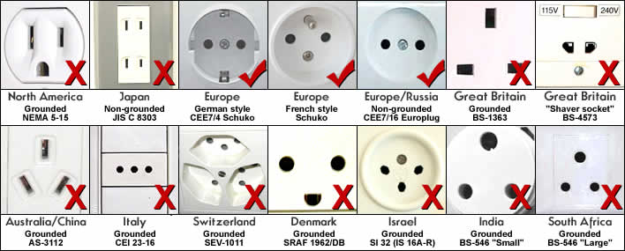

3. Business Hours

3.1. Museums
Most of Warsaw museums open their doors the whole week.The daily opening times vary from museum to museum, but most museums will be open between 09:00 am and 6:00 pm. During the weekend some musuems close a bit earlier

3.2. Shops
In Poland there is no opening time restrictions. Some shops therefore are open 24/7.Anyway, most of the malls closearound Supermarkets in cities and tourist centers often have open weekdays 6-22 clock and on weekends to 13 clock, in some large shopping centers you can shop around the clock.Department stores usually open weekdays 9-20 clock. Souvenir shops are usually open weekdays 9-19 clock.

3.3. Banks
In general banks are open from Monday to Friday from 08:30-17:30 and many banks are closed at lunchtime. Some banks are open Saturday morning and closed on Mondays. There are 24-hour automatic tellers around the city, and most offer international services.

3.4. Restaurants and warm meals
The lunch is served from 12 am to 2 pm. A lot of restaurants offers a cheap menu, but it's still difficult to get a good place in the restaurants because a lot of employed person don't go home for lunch. The dinner is served between 7 pm and 10 pm. Afterwards it's quite difficult to get a hot meal.

3.5. Post offices
The branches of the Polish Post Office (poczta) sell national and international stamps, sell phone cards and send faxes. Most offices are open from Monday to Friday, 8 am - 8 pm.

4. Money needs
The złoty , which literally means "golden", is the currency of Poland
Though it can take time to find a place where they accept travellers' cheques, you will succeed in the end. Banks are open on weekdays usually until 3pm - 6pm. Even better exchange rates are available in the numerous kantors (exchange offices - shop around to find the best deal) or at post offices. You can check the national bank rates at www.nbp.pl

Conversions
1 USD = approximately 3.0 PLN
1 GBP = approximately 4.7 PLN
1 EUR = approximately 3.9 PLN

5. Tipping
When you're paying for drinks or a meal in restaurants or bars and you get the cheque, you should give the amount you have to pay and wait for the change. If you give the money and say "thank you" it will be treated as "keep the change" type of tip. This also goes for taxis but in general tipping taxi drivers is uncommon but you can do that if you want. The average tip is around 10-15% of the cheque. Tipping is not obligatory, you can tip whoever you want to show that the service was good.

6. Climate
Poland lies in a moderate zone with mixed continental and oceanic climate influences. The warmest areas of the country are the Silesian Lowland and Sandomierska Upland, while the “coldest pole” of Poland is the town of Suwalki on the north-eastern edge of the country.

 | Average temperature | Average precipitation
January | -3.3 °C / 26.1 °F | 21 mm
February | -2.1 °C / 28.2 °F | 20 mm
March | 1.9 °C / 35.4 °F | 23 mm
April | 7.7 °C / 45.9 °F | 15 mm
May | 13.5 °C / 56.3 °F | 58 mm
June | 16.7 °C / 62.1 °F | 70 mm
July | 18.0 °C / 64.4 °F | 68 mm
August | 17.3 °C / 63.1 °F | 61 mm
September | 13.1 °C / 55.6 °F | 42 mm
October | 8.2 °C / 46.8 °F | 35 mm
November | 3.2 °C / 37.8 °F | 41 mm
December | -0.9 °C / 30.4 °F | 32 mm

