INTERNATIONAL ORGANISATION FOR STANDARDISATION
ORGANISATION INTERNATIONALE DE NORMALISATION
ISO/IEC JTC 1/SC 29/WG 11
CODING OF MOVING PICTURES AND AUDIO

ISO/IEC JTC 1/SC 29/WG 11 N13901
Geneva, CH – November 2013

Source: | Anthony Vetro
Title: | MPEG 107 Logistic Information
Purpose | Information

Logistic Information
The 107th ISO/IEC JTC 1/SC 29/WG 11 (MPEG) Meeting
2013 January 13-17 / San Jose, US

Meetings and Dates
MPEG AHG Meetings | Saturday, 11 January | Sunday, 12 January
MPEG | Monday, 13 January | Friday, 17 January
JCT-VC | Thursday, 9 January | Friday, 17 January
JCT-3V | Saturday, 11 January | Friday, 17 January
JPEG | Monday, 13 January | Friday, 17 January
VCEG | Saturday, 11 January | Friday, 17 January

Meeting Venue

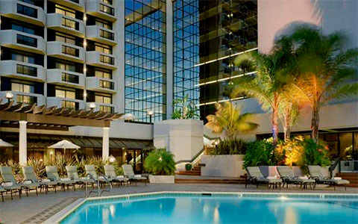

All meetings will be held at the DoubleTree by Hilton San Jose.

2050 Gateway Place
San Jose, CA 95110 USA
Phone: +1-408-453-4000
Fax: +1-408-437-2898
www.doubletreesanjose.com

Meeting Web Site
Meeting information, registration, hotel information and local information can be found at the following web site.

http://www.registrationassistant.com/meetingplanit/incits_l3/2014/index.html

Meeting Host
INCITS L3 (InterNational Committee for Information Technology Standards. Coding of Audio, Picture, Multimedia and Hypermedia Information)

Meeting Organizer
Julie Higgins
Meeting Planit
jhiggins@meetingplanit.com
Phone & Fax: +1-612-922-5986

Destination Information
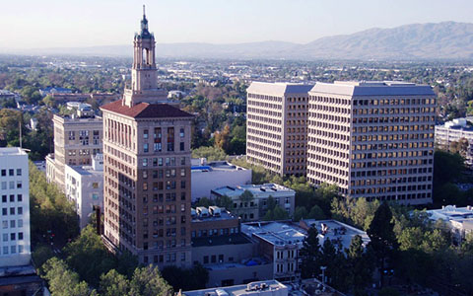

The meeting venue is in the heart of Silicon Valley, one quarter mile from the San Jose International Airport, 45 minutes south of the San Francisco International Airport, and one hour north of Monterey/Carmel.

Social Event

A social event will be held Wednesday, 15 January from 18:30 − 21:00 at the Computer History Museum.

Travel Documents and Visas
If an invitation letter is required:
- Fill out the request form
- Please send completed form to Kristin Califra from ANSI to receive an official invitation letter. One form per delegate.

Registration and Information Desk

The registration and information desk hours are: Thursday, 9 January to Friday, 17 January from 8:00 to 18:00.

Name Badges: You will receive your name badge upon check-in at the Registration and Information Desk. Your name badge is required for admittance into meeting rooms, breakfasts and breaks.

Facilities Fee

The facilities fee includes:
- meeting rooms with wireless Internet access, A/V equipment and power plugs
- daily continental breakfast and two coffee breaks
- a dedicated, staffed registration and information desk

$475.00 USD early birds, until 1 December 2013
$525.00 USD 2 December 2013 – 8 January 2014
$550.00 USD On site, starting 9 January 2014

Additional tickets for social will be made available for $50.

To register for the meeting, click here.
To reserve hotel rooms, click here.

Cancellation Policy

Cancellations before Friday, 13 December 2013: 100% refund

Cancellations after Friday, 13 December 2013 and before 3 January, 2014: 70% refund

Hotel Guest Room Cancellation

Refunds will be made only on reservations cancelled more than 72 hours prior to arrival. There will be a one (1) night charge for any reservation cancelled within 72 hours of your arrival date.

Currency/Credit Cards
The facilities fee may be pre-paid by Visa, Mastercard, or American Express credit cards, or by company check or wire. Alternatively, you may pay with US dollars or travelers checks on site.

Accommodations
DoubleTree by Hilton San Jose
2050 Gateway Place
San Jose, CA 95110 USA
Phone: +1-408-453-4000
Fax: +1-408-437-2898
www.doubletreesanjose.com

The hotel accepts Visa, Mastercard, American Express, Diners and Discover cards. A bank money dispensing machine is located in the hotel.
To make hotel reservations, click here.

The group rate is $149.00 per night, plus tax. The group rate will be available until Friday, December 20, 2013.

Hotel Guest Room Cancellation: Refunds will be made only on reservations cancelled more than 72 hours prior to arrival. There will be a one (1) night charge for any reservation cancelled within 72 hours of your arrival date.

Getting To the Hotel
The Hotel Provides Complimentary Transportation from San Jose International Airport
Pick up Courtesy Phone in Baggage Claim or call 408-453-4000 for courtesy shuttle pickup
Daily Schedule: 5:00 AM to 12:00 Midnight

Shuttle Companies from the San Francisco Airport

Monterey Airbus
www.monteryairbus.com
831-373-7777

A Best Shuttle
www.1abestshuttle.com/
866-333-2378

By Car
From San Jose International Airport: Follow signs for Hwy. 101 North/Airport Parkway. Stay in the right hand lane. Turn Right on to Airport and continue East. At the first light, turn Left onto Gateway Place. Hotel will be on the right.

From Hwy. 101 South: Exit North First St./Brokaw Rd. Make the first Right onto Airport Parkway. Hotel will be on the right.

From Hwy. 101 North: Exit Brokaw Rd. Make the first Left onto Brokaw Rd. and proceed under Hwy. 101. Hotel will be on the right.

From 880 North: Exit First Street. Make the first Left and go 3/4 of a mile North. Turn Left on Brokaw Rd. Hotel will be on your right.

From 880 South: Exit Brokaw Road. Turn Right on to Brokaw and go 1 mile, passing First Street. Hotel will be on your right.

From 280 North: Take 87 North Guadalupe Parkway towards downtown. Exit Skyport Drive. Make the first Right onto Skyport Drive. Turn Left at the next light, Technology Drive. Pass Airport Parkway. Hotel is on your right.

From 280 South: Take 87 North Guadalupe Parkway towards downtown. Exit Skyport Drive. Make the first Right onto Skyport Drive. Turn Left at the next light, Technology Drive. Pass Airport Parkway. Hotel is on your right.

Parking
Self-Overnight: $10.00
Valet Overnight: $21.00

Hotel Amenities
Complimentary airport shuttle (See “Getting to the DoubleTree San Jose” above)
Radio and Alarm clocks with MP3
High Speed wired and wireless internet
Remote guest room printing
Coffeemaker and complimentary coffee
Five in-hotel dining options with many restaurants within walking distance
Outdoor swimming pool, hot tub and fitness center
Warm chocolate chip cookies at check-in

Local Area Information
San Jose is the third largest city in California, the tenth largest in the U.S. The meeting venue is in the heart of Silicon Valley, one quarter mile from the San Jose International Airport, 45 minutes south of the San Francisco International Airport, and one hour north of Monterey/Carmel. See www.sanjose.org.

There are many restaurants within walking distance from the meeting venue.

Entertainment and recreation nearby the hotel include:
Casino M8trix
Paramount’s Great America
Winchester Mystery House
Children's Discovery Museum
Great Mall of the Bay Area - outlet shopping, 5 miles NE
SAP Center, 3 miles S
Monterey/Carmel, 50 miles SW
Overfelt Chinese Cultural Garden, 3 miles SE
Raging Waters, 3 miles S
San Francisco, 40 miles NW
San Jose Museum of Art, 4 miles SE
San Jose State University, 2 miles S
Santa Clara Convention Center, 3 miles NE
Santa Clara University, 2 miles SW
Santa Cruz Beach, 30 miles W
Santana Row - shopping, dining, 4 miles SW
Tech Museum of Innovation, 3 miles S
Valley Fair Mall, 4 miles SW

Time Zone
San Jose is on Pacific Standard Time (PST) and 8 hours behind Greenwich Mean Time.

Climate
The average high in January is 60F with a low of 45F.
The average monthly rainfall is 1.2 inches.

Electricity
The voltage in California is 110V. Two-pin plugs are standard.

