INTERNATIONAL ORGANISATION FOR STANDARDISATION

ORGANISATION INTERNATIONALE DE NORMALISATION

ISO/IEC/JTC 1/SC 29/WG 11

CODING OF MOVING PICTURES AND AUDIO
ISO/IEC JTC 1/SC 29/WG 11 N10878
October 2009 – Xian, CN

Source: | Convener of MPEG | 
Status: | Approved by WG11
Subject: | MPEG Press Release
Date: | 30 October, 2009

MPEG readies the standard for rich user experiences in internet television

Xian, China – The 90th MPEG meeting was held in Xian, China from the 26th to the 30th of October.

Highlights of the 90th Meeting

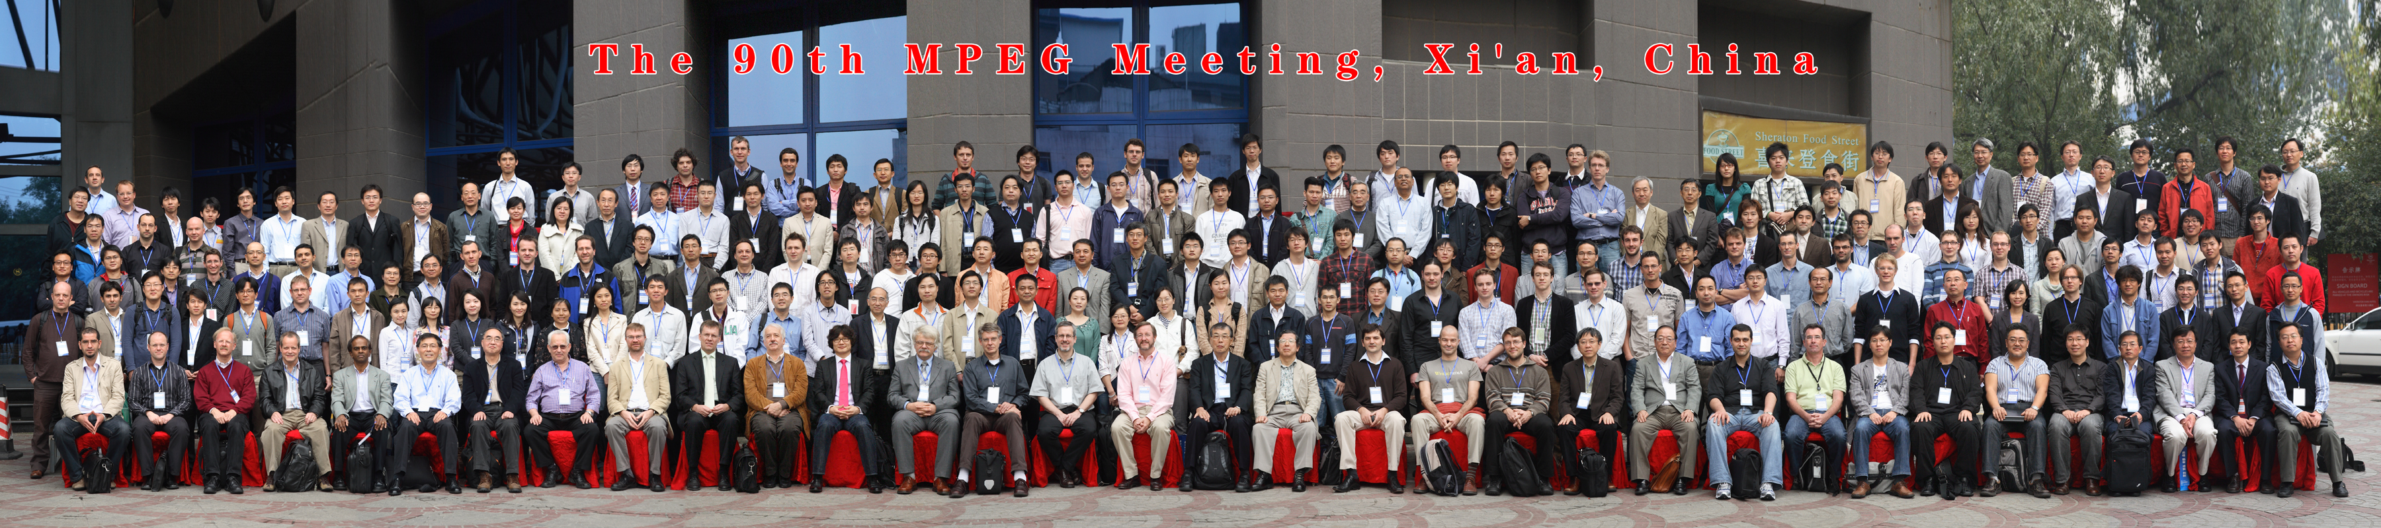

MPEG paves the way for the representation of metadata to enhance the IPTV user experience

MPEG has completed the final standardization (ISO/IEC 14496-20 AMD3) of the technologies enabling the integration of metadata for the creation of rich user experiences for multimedia services such as IPTV. For IPTV services, the provisioning of services and content using very detailed metadata is of primary importance, and the key to success is to provide a rich representation of such information to enable the user to select among these services and content based on their personal interests. The new standard will facilitate the easy and efficient integration of the structured metadata used for this purpose.

Reference software standard is now available for Professional Archival Application format

MPEG has delivered the final reference software standard for the Professional Archival Application Format (ISO/IEC 23000-6) which defines a packaging format for digital files. This standard will fulfill the industry need for an interoperable multimedia content archival format for the preservation of multimedia content. Several advanced features of the standard include comprehensive metadata to model all information necessary to support and preserve digital files, a flexible mechanism to pre-process digital files prior to their storage in archives, and a robust file format to allow easy access to both metadata and archived files.

MPEG amends its query format for efficient web search requests

MPEG has completed the first step toward enhancing its query format standard for fast and efficient web search requests. The MPEG Query Format standard (ISO/IEC 15923-12) or MPQF defines three main components: the Input Query Format to describe query requests to multimedia retrieval systems, the Output Query Format, a message container for retrieval results, and the Query Management Tools supporting service discovery, service aggregation and service capability descriptions. A new amendment to MPQF will enable the retrieval of data from an ontology (a rigorous representation of web data that describes the relationships amongst these data to facilitate their efficient retrieval) adding semantic expressions that can be used in request and result data representations, as well as a query type for SPARQL, a language supporting semantic web environment.

MMT workshop targets requirements and technologies for streaming of MPEG content

The Workshop for MPEG Media Transport (MMT) will be held on 20 January 2010 during the 91st MPEG meeting at the Kyoto Research Park in Kyoto, Japan. The purpose of this event is to gather new requirements, use cases, and contributions related to the transport of multimedia content over heterogeneous networks. In particular, MPEG is gathering information on current limitations of available standards and new technologies in the area of media progressive download and streaming, delivery of MPEG media across emerging network environments, quality of service/experience as well as cross layer technologies.

MPEG plans to start a new standardization project on MMT with a Call for Proposals to be issued at the 91st meeting. The new standard is planned to reach the Final Draft International Standard stage in July 2011.

The MMT workshop is also free of charge. For more information, visit http://www.chiariglione.org/mpeg/hot_news.htm

Contact MPEG

Digging Deeper Once Again
Communicating the large and sometimes complex array of technology that the MPEG Committee has developed is not a simple task. The experts past and present have contributed a series of white-papers that explain each of these standards individually. The repository is growing with each meeting, so if something you are interested is not there yet, it may appear there shortly – but you should also not hesitate to request it. You can start your MPEG adventure at: http://www.chiariglione.org/mpeg/mpeg-tech.htm

Ends

Further Information
Future MPEG meetings are planned as follows:
No. 91, Kyoto, JP, 18-22 January, 2010
No. 92, Dresden, DE, 19-23 April, 2010
No. 93, Geneva, CH, 26-30 July, 2010
No. 94, Guangzhou, CN, 11-15 October, 2010
For further information about MPEG, please contact:
Dr. Leonardo Chiariglione (Convener of MPEG, Italy)
Via Borgionera, 103
10040 Villar Dora (TO), Italy
Tel: +39 011 935 04 61
Email: mailto:leonardo@chiariglione.org
or
Dr. Arianne T. Hinds
Ricoh | IBM InfoPrint Solutions Company
6300 Diagonal Highway, MS 04N
Boulder, CO 80301, USA
Tel +1 720 663 3565
Email: arianne.hinds@infoprint.com
This press release and other MPEG-related information can be found on the MPEG homepage:
http://www.chiariglione.org/mpeg
The text and details related to the Calls mentioned above (together with other current Calls) are in the Hot News section, http://www.chiariglione.org/mpeg/hot_news.htm. These documents include information on how to respond to the Calls.
The MPEG homepage also has links to other MPEG pages which are maintained by the MPEG subgroups. It also contains links to public documents that are freely available for download by those who are not MPEG members. Journalists that wish to receive MPEG Press Releases by email should contact Dr. Arianne T. Hinds using the contact information provided above.

