ISO/IEC JTC 1/SC 29/WG 11
Coding of moving pictures and audio
Convenorship: UNI (Italy)
Document type: Press Release
Title: Press Release of 128th MPEG Meeting
Status: Approved
Date of document: 2019-10-11
Source: Convenor
Expected action: INFO
No. of pages: 4
Email of convenor: leonardo@chiariglione.org
Committee URL: https://isotc.iso.org/livelink/livelink/open/jtc1sc29wg11

INTERNATIONAL ORGANISATION FOR STANDARDISATION
ORGANISATION INTERNATIONALE DE NORMALISATION
ISO/IEC JTC 1/SC 29/WG 11
CODING OF MOVING PICTURES AND AUDIO
ISO/IEC JTC 1/SC 29/WG 11 N18751
Geneva, CH – October 2019

Source: | Convenor of ISO/IEC JTC 1 SC 29/WG 11 (MPEG) | 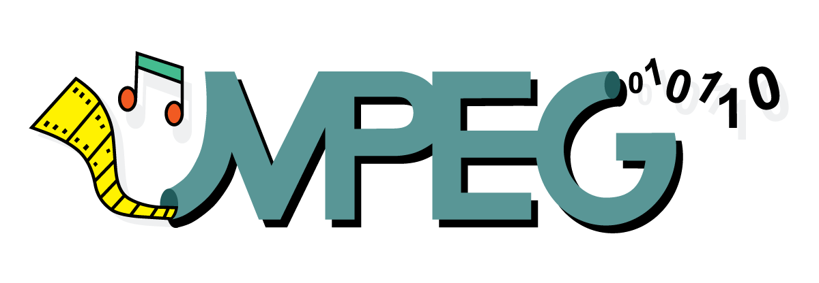
Status: | Approved by WG11
Subject: | WG 11 (MPEG) Press Release
Date: | 11 October 2019
Low Complexity Enhancement Video Coding (LCEVC) Promoted to Committee Draft
Geneva, Switzerland – The 128th WG 11 (MPEG) meeting was held in Geneva, Switzerland, 07-11 October 2019

Low Complexity Enhancement Video Coding (LCEVC) Promoted to Committee Draft
At its 128th meeting, WG11 (MPEG) promoted ISO/IEC 23094-2 Low Complexity Enhancement Video Coding (MPEG-5 Part 2 LCEVC) to Committee Draft (CD). The goal of MPEG-5 Part 2 LCEVC is to provide a standardized video coding solution that leverages other video codecs in a manner that improves video compression efficiency while maintaining or lowering the overall encoding and decoding complexity.
The MPEG-5 Part-2 LCEVC standard uses a lightweight video codec to add up to two layers of encoded residuals. The aim of these layers is correcting artefacts produced by the base video codec and adding detail and sharpness for the final output video.
The target of this standard comprises software or hardware codecs with extra processing capabilities, e.g., mobile devices, Set Top Boxes (STBs), and PC-based decoders. Additional benefits are the reduction in implementation complexity or a corresponding expansion in spatial resolution.
2nd Edition of Omnidirectional Media Format (OMAF) has reached the first milestone
At its 128th meeting, WG11 (MPEG) promoted the 2nd edition of the ISO/IEC 23090-2 Omnidirectional Media Format (OMAF) standard to Committee Draft (CD). This 2nd edition introduces new technologies including (i) support of improved overlay of graphics or textual data on top of video, (ii) efficient signaling of videos structured in multiple sub parts, (iii) enabling more than one viewpoint, and (iv) new profiles supporting dynamic bitstream generation according to the viewport. The encapsulation and signaling of new metadata storage in ISOBMFF are specified as a part of this specification in order to support these new features. Additionally, the streaming of omnidirectional media adopting, for example, dynamic adaptive streaming over HTTP (DASH, ISO/IEC 23009-1) and MPEG media transport (MMT, ISO/IEC 23008-1) is also specified as well as new media and presentation profiles. The 2nd edition of OMAF will reach its final milestone by the end of 2020.
Genomic Information Representation – Part 4 Reference Software and
Part 5 Conformance Promoted to Draft International Standard
WG 11 (MPEG) and ISO TC 276/WG 5 have addressed the emerging problem of managing the large quantities of genomic sequencing data by developing the ISO/IEC 23092 standard series also known as MPEG-G. These standards provide the specification of (i) a file and transport format (Part 1), (ii) compression technology (Part 2), and (iii) metadata specifications, protection support, and standard APIs for the access of sequencing data in the native compressed format (Part 3).
In line with the traditional MPEG practice, at its 128th meeting, MPEG promoted ISO/IEC 23092-4 MPEG-G Part 4 “Reference Software” and ISO/IEC 23092-5 MPEG-G Part 5 “Conformance” to Draft International Standard (DIS) status. Such components of the MPEG-G standard series provide important support to companies and individuals willing to implement the standard and willing to verify the correctness and interoperability of their own implementations.
The MPEG-G Reference Software standard provides one implementation of the standard in the form of an open source package and, thus, complements the textual specification with an example of executable decoders for Part 1 and Part 2 of the standard. It is worth emphasizing that the reference software source code has been written with the solely objective of specifying and clarifying all the details of the standard decoding processes. Therefore, although the reference software can be used as is provided, or can be used as a starting point for any implementation purposes, it has also to be underlined that its direct usage might provide runtime performance that are well inferior to those achievable by other implementations fully developed and optimized to achieve all the potential of the MPEG-G standard.
The MPEG-G Conformance standard provides a specification of the behavior of conformant decoder implementations by describing a rich set of tests and providing input data as well as the corresponding golden reference that conformant decoders should exhibit.
By completing these supporting standard parts, the development of the MPEG-G standard series has reached the status for which deployment of interoperable applications based on native MPEG-G representation can start at full speed.
How to contact WG 11 (MPEG), learn more, and find other MPEG facts
To learn about MPEG basics, discover how to participate in the committee, or find out more about the array of technologies developed or currently under development by WG 11 (MPEG), visit WG 11 (MPEG)’s home page at https://mpeg.chiariglione.org/. There you will find information publicly available from WG 11 (MPEG) experts past and present including tutorials, white papers, vision documents, short articles and requirements under consideration for new standards efforts. You can also find useful information in many public documents by using the search window including publicly available output documents of each meeting (note: some may have editing periods and in case of questions please contact Dr. Christian Timmerer).
Examples of tutorials that can be found there include tutorials for: High Efficiency Video Coding, Advanced Audio Coding, Universal Speech and Audio Coding, and DASH to name a few. A rich repository of white papers can also be found and continues to grow. You can find these papers and tutorials for many of WG 11 (MPEG)’s standards freely available. Press releases from previous WG 11 (MPEG) meetings are also available.
Journalists that wish to receive WG 11 (MPEG) Press Releases by email should contact Dr. Christian Timmerer at christian.timmerer@itec.uni-klu.ac.at or christian.timmerer@bitmovin.com or subscribe via https://lists.aau.at/mailman/listinfo/mpeg-pr. For timely updates follow us on Twitter (https://twitter.com/mpeggroup).
Further Information
Future WG 11 (MPEG) meetings are planned as follows:
No. 129, Brussels, BE, 13 – 17 January 2020
No. 130, Alpbach, AT, 20 – 24 April 2020
No. 131, Geneva, CH, 29 June – 03 July 2020
No. 132, Rennes, FR, 12 – 16 October 2020

For further information about WG 11 (MPEG), please contact:
Dr. Leonardo Chiariglione (Convenor of WG 11 (MPEG), Italy)
Via Borgionera, 103
I-10040 Villar Dora (TO), Italy
Tel: +39 011 935 04 61
leonardo@chiariglione.org

or

Priv.-Doz. Dr. Christian Timmerer
Alpen-Adria-Universität Klagenfurt | Bitmovin Inc.
9020 Klagenfurt am Wörthersee, Austria, Europe
Tel: +43 463 2700 3621
Email: christian.timmerer@itec.aau.at | christian.timmerer@bitmovin.com

