INTERNATIONAL ORGANIZATION FOR STANDARDIZATION
ORGANISATION INTERNATIONALE DE NORMALISATION
ISO/IEC JTC1/SC29/WG11
CODING OF MOVING PICTURES AND AUDIO

ISO/IEC JTC1/SC29/WG11 N14115
January 2014

Source | Leonardo Chiariglione - Convenor
Title | MPEG 108 meeting notice and logistic information

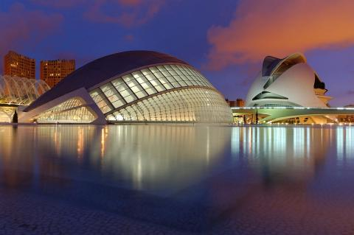
Date:
Monday, 31 March 2014 to Friday, 4 April 2014
Venue:
Hotel Meliá Valencia Palacio De Congresos
Av. Cortes Valencianas 52
46015 Valencia ES
Spain
Meeting link:
Palacio de Congresos de Valencia

General information
All meetings are hosted by Universidad Politécnica de Madrid.
For latest informations please check http://www.kcmweb.de/conferences/mpeg108 .

Meeting venue
Palacio de Congresos de Valencia
Av. Cortes Valencianas, 60 - 46015 Valencia - Spain
Tel. +34.963179400 - http://www.palcongres-vlc.com

Meeting organizer
kenzler conference management
Silke Kenzler
Karla-Schmidt-Str. 14
D-30655 Hannover
Germany
Tel. +49.51165581860
office@kcmweb.de

Registration
Facility fees for all meetings
Advanced registration  (until 2014-02-19) | Regular rate  (from 2014-02-20)
430 EUR | 530 EUR

Cancellation penalties
- 50 EUR before 2014-03-08.
- 50% before 2014-03-22.
- No refund from and after 2014-03-23.

Facility fee includes
- Meeting facilities, including A/V equipment and wireless Internet access.
- Coffee-breaks.

Registration
Please make your registration here.
For questions regarding payment please contact kenzler conference management.

Visa information
Citizens of all countries of the European Union, Switzerland, Croatia, Israel, Japan, Australia, New Zealand, most of the countries of North and South America, and some other countries do not need a visa: a valid passport suffices to enter Spain. In case of doubt please contact the Spanish Ministry of Foreign Affairs and Cooperation well in advance before departure.
Travellers requiring a visa can travel freely throughout the Schengen zone for three months with a Schengen visa issued by any Schengen country. Obtaining a visa entitling you to visit one Schengen country automatically entitles you to travel to and from all the other Schengen countries too.
If you need a letter of invitation, please fill out the template letter below and send it by email to kenzler conference management as early as possible, in order to leave plenty of time to process the application. We suggest submitting it before 2014-02-01.
invitation letter

Hotels

Hotel | Signature  on map | Distance to |  | Room price | Booking  form
Hotel | Signature  on map | conf. center | city | Single (Double) | Booking  form
Sorolla Palace 4* | 2 | 50 m | 4,0 km | 85 (95) EUR | Form
Meliá Valencia 4* | 3 | 100 m | 4,0 km | 120 (140) EUR
Hotel Eurostars Gran  Valencia 4* | 4 | 650 m | 3,8 km | 119 (129) EUR | Form
Confortel Valencia 4* | 5 | 650 m | 3,8 km | 88 (99) EUR
Ibis Valencia Palacio de  Congresos 2* | 6 | 650 m | 3,8 km | 44 (51) EUR | Form
Hotel Petit Palace  Bristol 3* | 7 | 4,7 km | 1,0 km | 87 EUR
The River Hostel | 8 | 5,0 km | 500 m | 25 (35) EUR
Nest Hostels | 9 | 3,6 km | 650 m | 39 EUR
Please note: All prices include breakfast and taxes.
Check also online booking systems to get lower offers for the aforementioned hotels.

Room contingent
A contingent of rooms are reserved for the meetings at the following hotels:
Sorolla Palce, Hotel Eurostars Gran Valencia, Hotel Ibis Valencia Palacio de Congresos.
To book these rooms please fill out the form and send it directly to the hotel. Please note that we only have a limited allocation for these offer.

Restaurants/Shopping

Restaurants
Valencia is sea and mountains, it's a delicious gastronomy, and has a lot of hidden spots to be discovered. In this city the main ingredients to any dish consist in garden vegetables, fresh fish and seafood. Some of the main Valencian recipes are dishes like the famous paella, made of seafood or meat, or both if that is what you wish. Rice is an important element in most of the traditional dishes. Rice cooked in the oven, black rice with seasfood which is accompanies with the calamari ink to give the rice it's dark color. Fish is the main ingredient in typical recipes like "Fidegua" made up of noodles with fish and seafood sauce.

Valencia Shopping
You can go shopping in Valencia any day of the year. Although normal shop opening hours are from 10 am to 8.30 pm, you will find malls and shops in tourist areas that are open every day, including Sundays and public holidays (except 1 and 6 January, 1 May and 25 December).
The areas where shops are open every day of the week are:
- Jardín del Turia: from Nou d'Octubre bridge to Astilleros bridge
- Valencia city centre: Ciutat Vella and Ensanche areas
- Els Orriols: around Ciudad de Valencia stadium
Opening times please see F.A.Q.

Sightseeing

Valencia offers numerous attractive proposals to get you out and about all year round. Enjoy the Mediterranean nature of inland towns and villages; discover the charming coves and beaches of Alicante’s Costa Blanca; enjoy Benidorm’s intense day and night life; travel from tradition to modernity in Valencia Terra i Mar and dive into the best kept secrets of Castellón. Wherever you go, the Region of Valencia will surprise you.
Further informations you will find here.

The City of Arts and Sciences
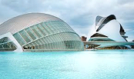
Everyone has seen Baroque, Renaissance and Gothic. But this time you are transported into the future, not into the past. The City of Arts and Sciences is a huge futuristic educational complex which is composed of 5 elements, all bound together in a luxurious landscape of clear water spaces and greenery. It is truly a city within a city - you will find yourself far, far away from Valencia, on some distant planet in a distant time.

The Turia Gardens
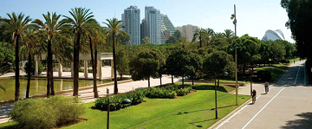
The Turia Gardens were created in the 20th after the catastrophic flood in 1957. The Garden includes 120 hectares of the riverbed which was diverted from the north to the south of the city in order to prevent future disasters. Nowadays you will find here a calm place to relax, sport fields to stay active or simply a possibility to do a walk through the city without traffic jam or annoying traffic lights.

The Port
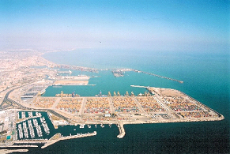
Valencia has the second busiest commercial port in Europe, and sea-trade has always been a huge part of the city's life. The Port is part of what Valencia is known for.

The Bioparc

The Bioparc is a less publicized place in Valenica but nevertheless worth seeing. It is a Zoo with a ‘Safari-Feeling’. You get to see dozens of animal species without glass or cages keeping them at bay.

The Old Town
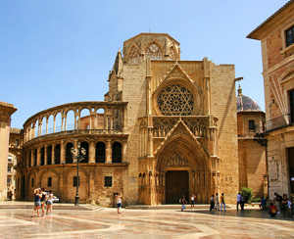
Valencia's old part of town is limited by the rails of the tramway, which run where have been the old town-walls until 1865. Most monuments date to the time after the reconquest of Valencia from the Moors, in 1238 by Jaime I.. That was the town's most blooming epoch.

F.A.Q.

Contents
1. Emergencies
2. Electricity
3. Business Hours
3.1 Museums
3.2 Shops
3.3 Banks
3.4 Restaurants and hot food
3.5 Post offices
4. Money needs
5. Tipping
6. Climate

1. Emergencies
In case the worst should happen, here are the most important telephone numbers in Valencia.
Fire Service: 080
Local Police: 092
Ambulance / rescue: tel. 061
Emergency doctor: tel.
European emergency: tel. 112
ViennaMed doctor's hotline for visitors (0-24): tel. +43-1-513 95 95
Evening and weekend dental service (taped service): tel. +43-1-512 20 78
Evening and Sunday drugstores (0-24): tel. 1455
0800-MEDICINE
The hotline 0800 633 42 46 offers a free initial consultation for medical problems and helps you find suitable measures to take. German, English, Italian, French. http://0800medicine.at/

2. Electricity
Standard electrical voltage in Valencia is 220-240 V AC, 50 Hz. A transformer and an adapter are necessary to use North American electrical appliances whose plugs have two square pins. Adapters are available in most hardware stores.

3. Business Hours

3.1. Museums
Most of Valencia's museums open their doors from Tuesday to Sunday. The daily opening times vary from museum to museum, but most museums will be open between 10.00 am and 8.00 pm. All details at Valencia's attractions.

3.2. Shops
Although shops are normally open from 10am to 1:30pm and from 5.30pm to 8.30pm, in some tourist areas they tend to stay open uninterruptedly from 10am to 8.30pm. Large department stores like El Corte Ingles or Fnac are open from 10am to 9.30pm.

3.3. Banks
Most banks are open from Monday to Friday between 8:30 a.m. and 2:30 p.m. Only a few branches open on Saturday mornings. There are 24-hour automatic tellers around the city, and most (Servired, 4B, etc.) offer international services.

3.4. Restaurants and hot food
Most restaurants open during the siesta ,normally 1.30-2pm to 4-4.30pm. They will then reopen only at 8-9pm and close at around midnight.
Tapas bars are open from about 10 am to about midnight.

3.5. Post offices
The Central Post and Telegraph Office (Plaza del Ayuntamiento, 24) is open on weekdays from 8:30 a.m. to 8:30 p.m. and between 9:30 a.m. and 2:00 p.m. on Saturdays. Telephone: 96 310 27 30. Stamps are also available in all tobacconists.

4. Money needs
The currency in Spain is the Euro. You can also pay for your purchases without problem by card.
Most hotels, restaurants and shops in Valencia accept the main credit cards such as American Express, VISA, Mastercard, 4B, Access y Diners Club.
Exchanging money:
RIA Money Transfer & Change:
Currency exchange, traveller’s checks and money transfers. Centrally located in the main European cities.
Convento de Jerusalén, 9 46007 - Valencia
Tel.: +34 963 525 383

5. Tipping
Tips are included in all prices and bills, so tipping is not considered obligatory. However, if the service received is considered satisfactory, especially in bars and restaurants, a tip is often left.

6. Climate
Valencia enjoys a mild temperate Mediterranean climate. The average annual temperature is 17ºC with warm summers and very mild winters, rarely below 10ºC. There is only light rainfall mainly in autumn and the beginning of spring.


